IT IS THE VIRUS CRISIS!
_____________________________________

Hospitality and Registered Apprenticeship - It's What's for Dinner!

MEET AND GREET WITH CHEF ROBERT PATTON OF ARAMARK/OLD DOMINION UNIVERSITY
JIM WILSON OF VIRGINIA RESTAURANT, LODGING & TRAVEL ASSOCIATION
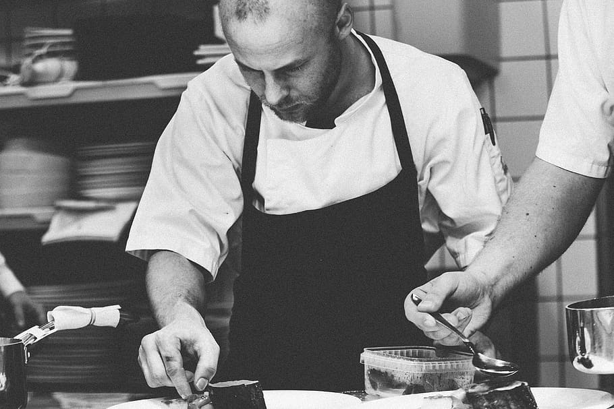
The goal of the Aramark at Old Dominion University Monarch Dining Apprenticeship program is to develop apprentices who learn skills on-the-job, which will serve them to develop into committed and dedicated culinarians and continued employees of Aramark and Monarch Dining.

Hear more from Chef Patton.

Another great Brown Bag in March gave us some highlights on the construction industry’s approach to creating and promoting an inclusive work environment. Thank you to all who joined the WebEx call.

Join us on Monday, April 26, 2021 when Aramark’s Chef Robert Patton and Virginia Restaurant, Lodging & Travel Association’s Jim Wilson discuss how the COVID pandemic has affected the restaurant and hospitality industries and how RA can help assist the industry.
Please invite others to join us.

Join in from 12:00 p.m to 1:00 p.m. EST with this quick Registration. Q & A will be available and different guests will be joining us throughout the year. Register here: (Note: link may need to be copied into your browser)
https://bit.ly/3rXYIGX

Virginia Registered Apprenticeship – Your Next Step:
https://www.youtube.com/watch?v=DEr__ZoTTk0

