VIRGINIA CAREER WORKS – PRINCE WILLIAM CENTER  13370 Minnieville Road  Woodbridge, VA 22192 | 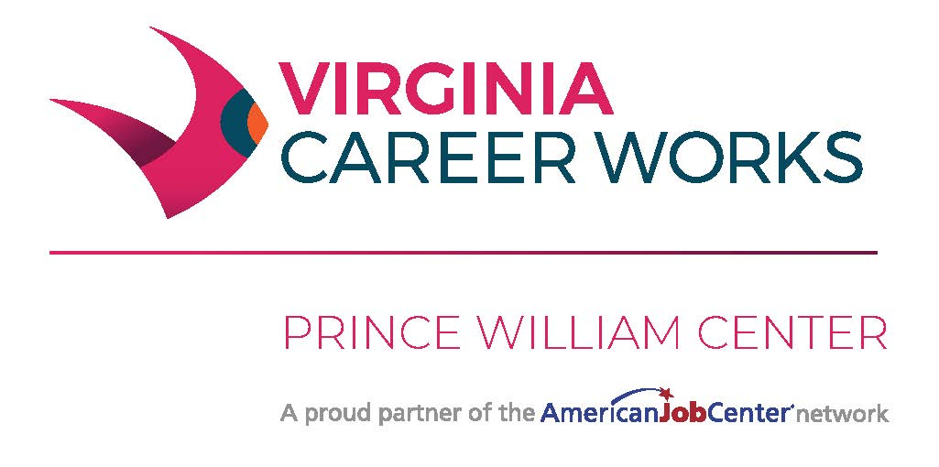
VIRGINIA CAREER WORKS
PARTNER AGENCY
Referral Form

CUSTOMER INFORMATION
 | Date
Name (Last, first, middle initial) | Last 4 Social Security #
Street address, City, ST, ZIP Code
Primary phone number | Other phone number | Email address
Type of Service Request
- Employment | - Veteran/Spouse | - Adult Basic Education
- Training  - Ticket to Work/Benefits Counseling  - 2nd Chance | - Assessments  - Financial Coaching | - Workshop/Hiring Event  - Healthcare
Please briefly describe information gathered from customer (purpose for visit, career planning goals, employment skills).
Please list [Company Name] staff members that were contacted regarding this matter:
Name Agency |  | Date
Name Agency |  | Date
Workforce Center Advisor Signature |  | Date
For Administrative Use Only:
 |  | Date received
Action taken
 |  | Date
Attach additional documentation, if applicable.

